

Dr. David, Baker inc.
2021-09-12
Dr. Baker
37452 Claudia Radial, East James, WY 78344
Phone: 914370394
Fax: 3315787234

Re: Lacey, Blair
PHN: 1660034260
Birthdate: 11-Dec-1950
Address: 216 Mary Spurs Apt. 457, Lake Jonathanfort, VI 33351
Patient number: 985168386

To Whom It May Concern:

This is a medical letter to state the above patient is pregnant with expected delivery date of 09-Aug-2025. Hoping this information is satisfactory for your requirements.

Thank you.

Sincerely,
Dr. David, Baker
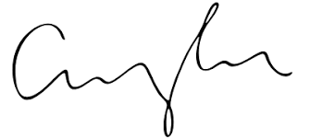
FRCS© NCMP
Clinical Assistant Professor, UBC
Department of Obstetrics and Gynecology SMH

